**User Manual for Roulette Winning Number Detection System**

This guide explains how to **set up, run, and use** the system step by step.

**System Overview**

This system **detects winning numbers in an online roulette game** using **YOLO for object detection** and **EasyOCR for text recognition**.  
**Key Features:**  
✅ Detects numbers from the **right 50% of the screen**  
✅ **Stores results in an Excel file**  
✅ **Real-time video streaming** in a web interface  
✅ **Start/Stop Detection with a button**

**System Requirements**

✅ **Operating System:** Windows 10/11 (or macOS/Linux)  
✅ **Python Version:** Python 3.8+  
✅ **Required Hardware:** Decent CPU & GPU for YOLO

**Environment Setup**

**Step 1: Install Python**

* Download and install Python from [python.org](https://www.python.org/downloads/)
* During installation, check **"Add Python to PATH"**

**Step 2: Create a Virtual Environment (Optional, but Recommended) and activate the environment.**

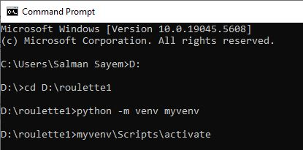

**Step 3: Install Required Libraries**

Run the following command to install dependencies:

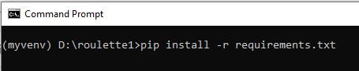

**Step 4: Start the Flask Server**

Run the following command:



If everything is correct, you’ll see:

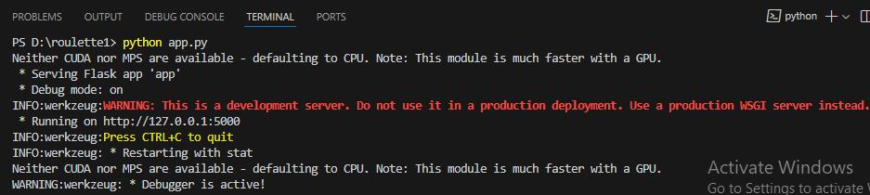

* Running on <http://127.0.0.1:5000>

Open this **URL in your browser**.

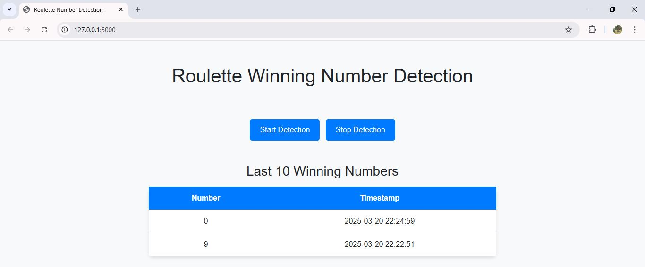

**Using the System**

**Web Interface**

Once the system is running, the web page allows you to:

* **Start Detection** → Click the "Start Detection" button
* **Stop Detection** → Click the "Stop Detection" button
* **View Processed Video** → The detected numbers are shown in real-time
* **Excel File (Results)** → Detected numbers are saved in **results/detected_numbers.xlsx**

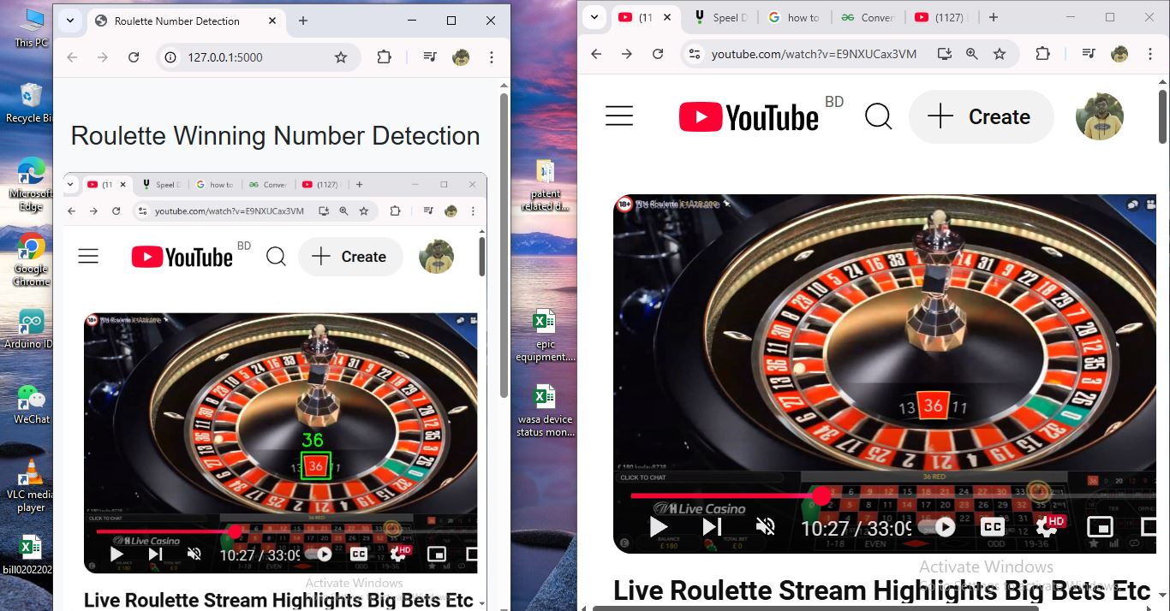

Winning number also will be showing to the UI

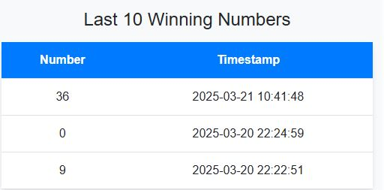

**Output Excel File Format**

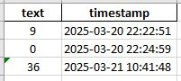

**Stopping the System**

To **stop the detection**, either:

1. Click **"Stop Detection"** on the web page
2. Press **CTRL + C** in the terminal

**Conclusion**

By following this guide, you can:

✔ **Set up the system**  
✔ **Run and use the detection**  
✔ **Save results in Excel**  
✔ **Customize the detection settings**

**Now you can start detecting winning numbers automatically!**